# UpGrad Capstone Project

## Workshop ID: DAT-V313-12022804 | DS | 30th July. 2023

Submitted By: Raman Kapoor ([rkapoor41212@gmail.com](mailto:rkapoor41212@gmail.com))

Project Title: FindDefault (Prediction of Credit Card Fraud)

The dataset contains transactions made by credit cards in September 2013 by European cardholders. This dataset presents transactions that occurred in two days, where we have 492 frauds out of 284,807 transactions. The dataset is highly unbalanced, the positive class (frauds) account for 0.172% of all transactions.

We have to build a classification model to predict whether a transaction is fraudulent or not.

**Import the Libraries and Read the Dataset**

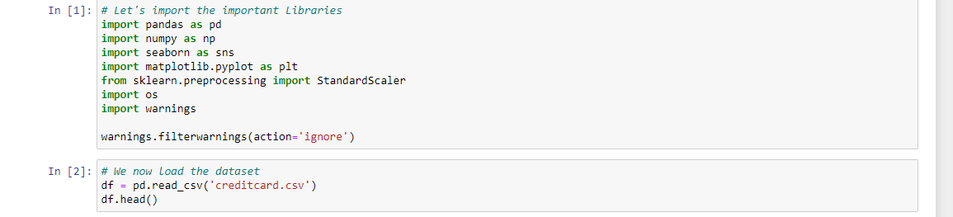

**Exploratory Data Analysis**

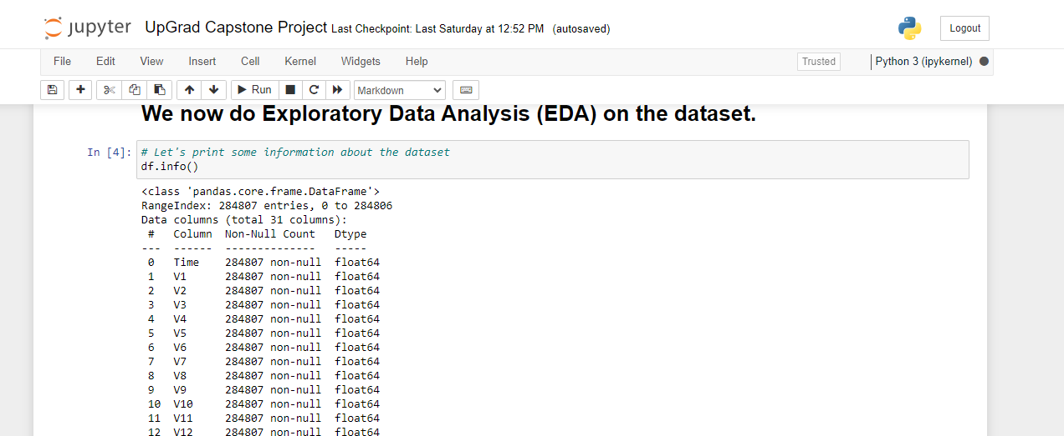

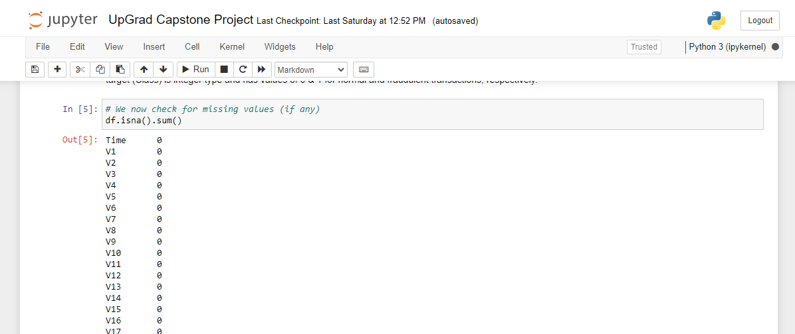

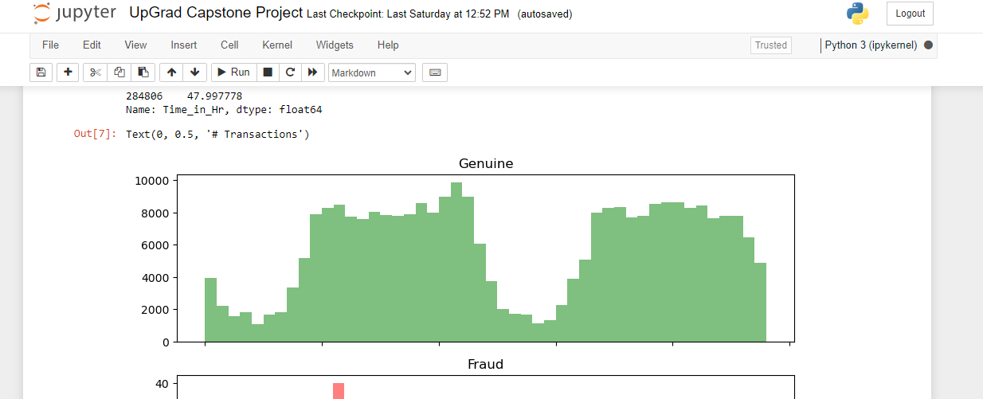

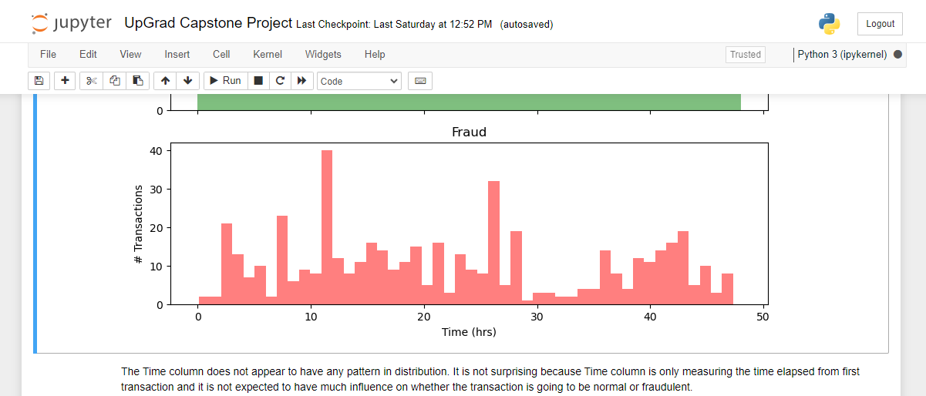

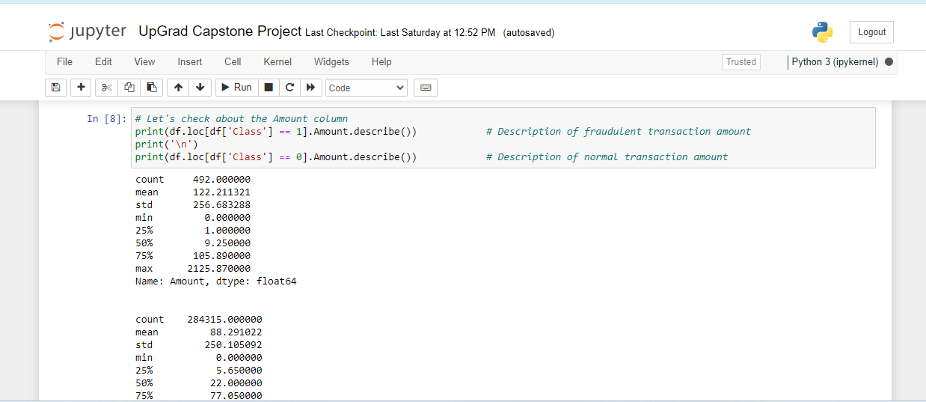

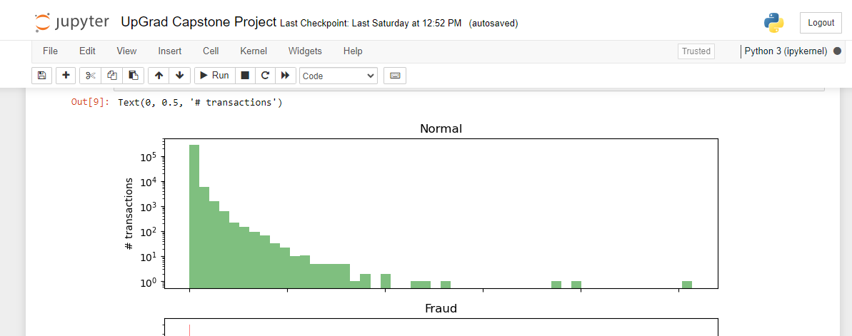

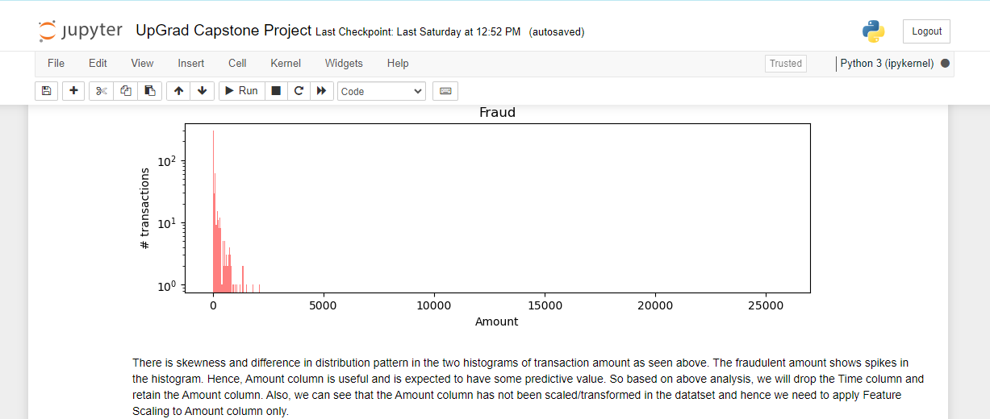

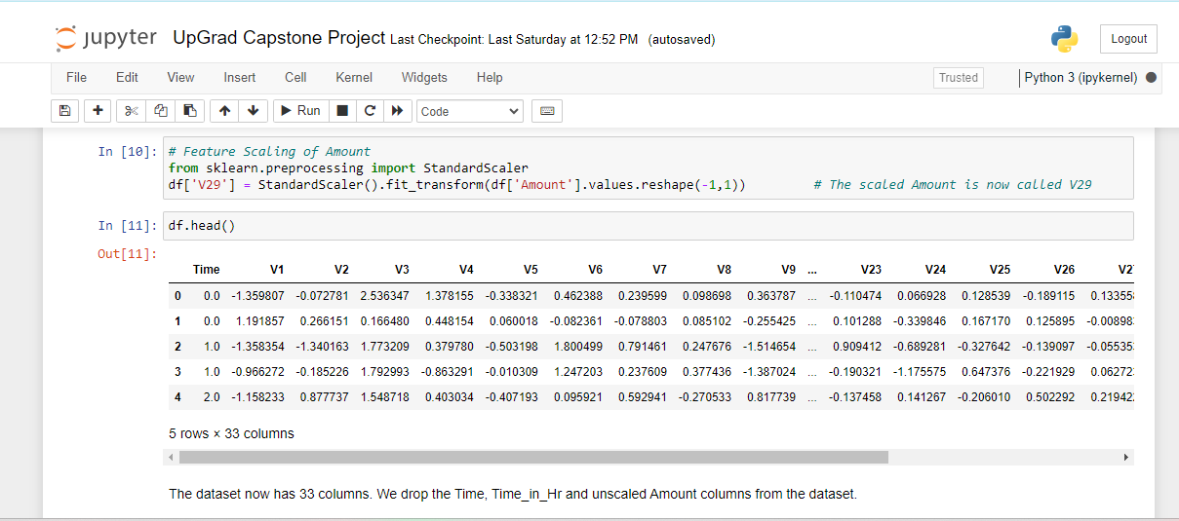

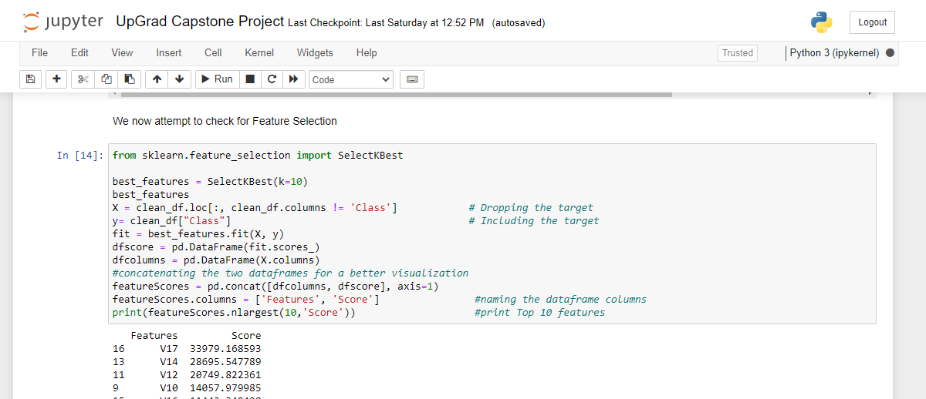

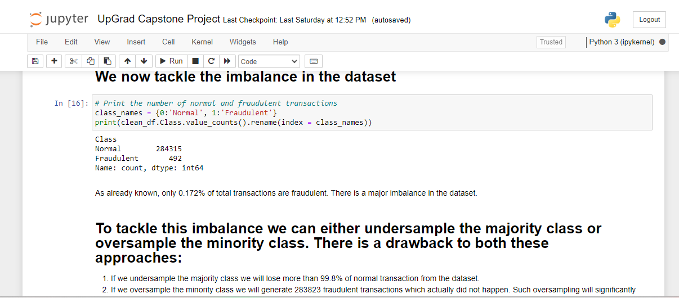

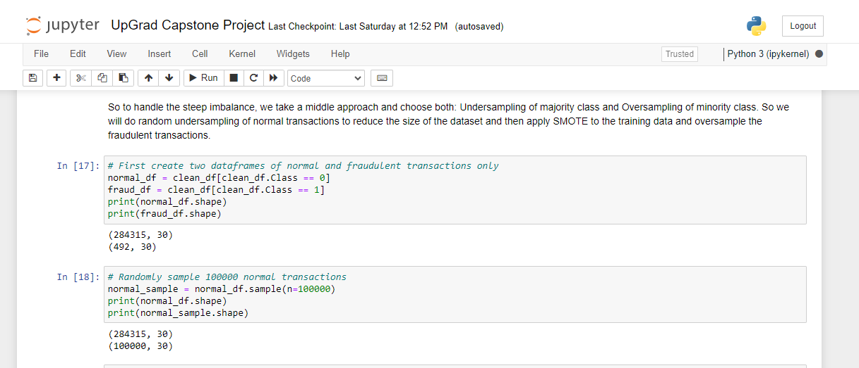

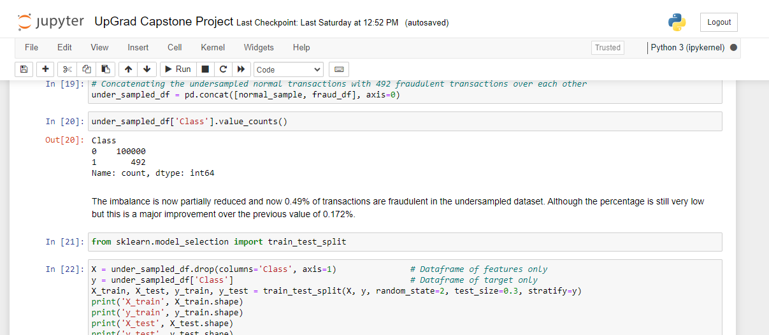

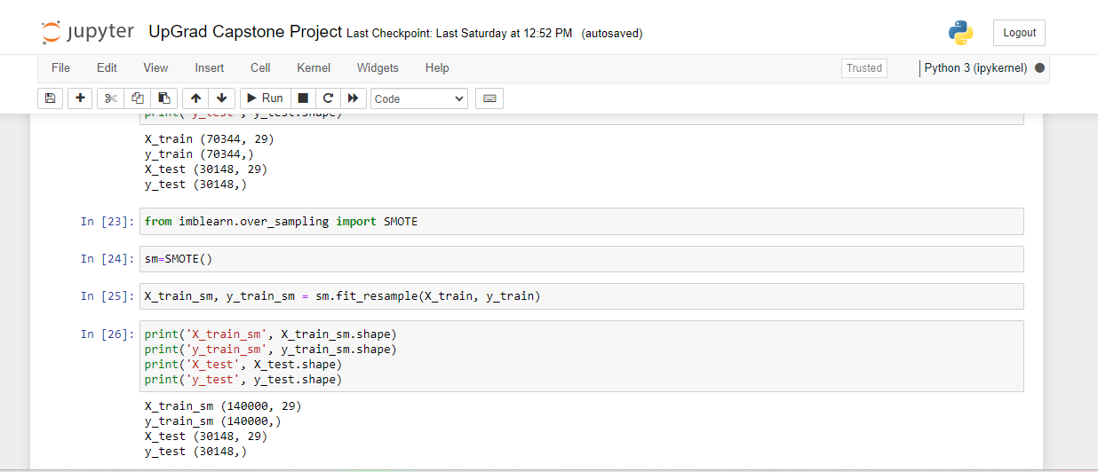

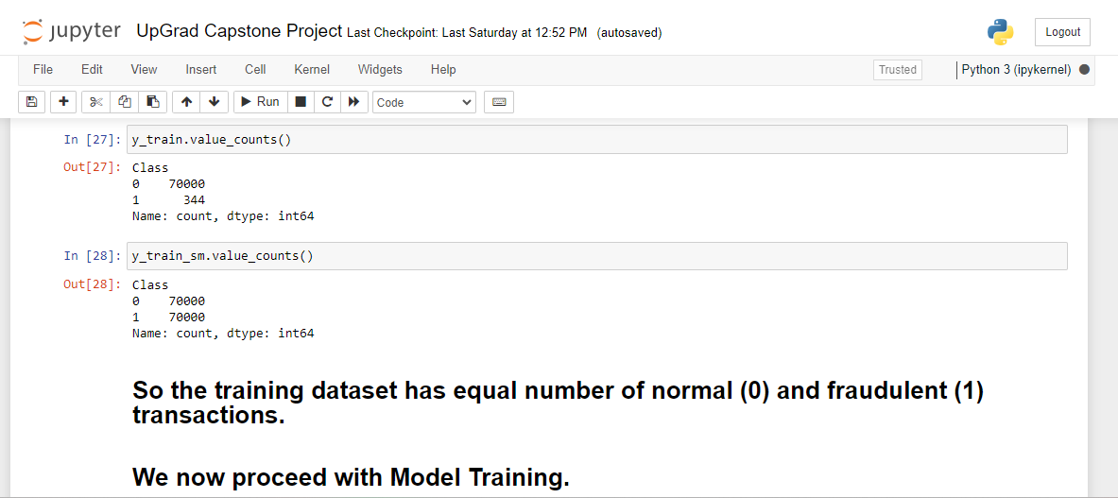

**Model Training**

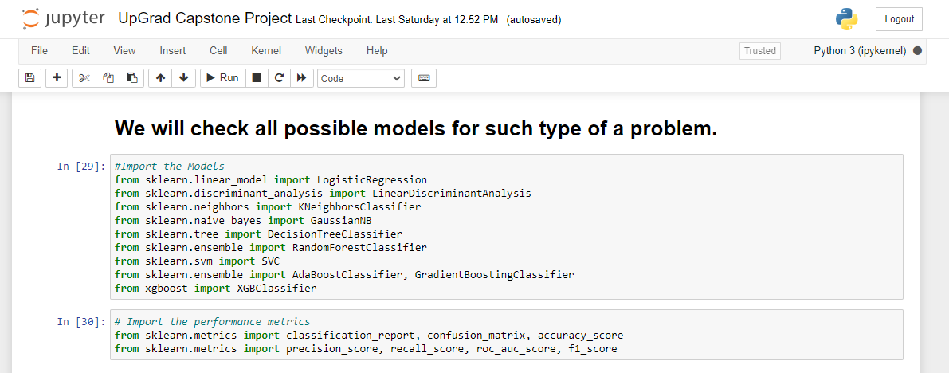

**Model Results**

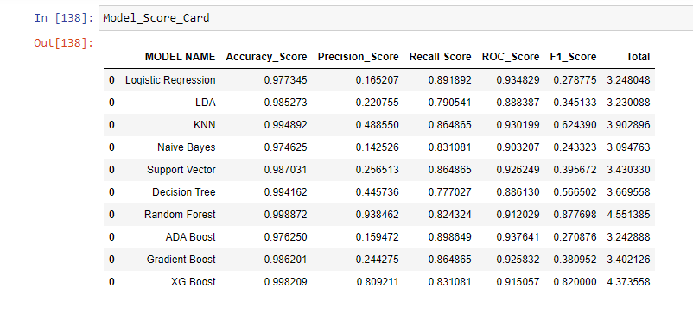

**HyperParameter Tuning on XGBoost**

